**Assignment 3 - Reporting on Data Aggregation and Transmission**

**Tasks**

1. Retrieve a list of directories from the FTP
   1. Output the directories to the Console

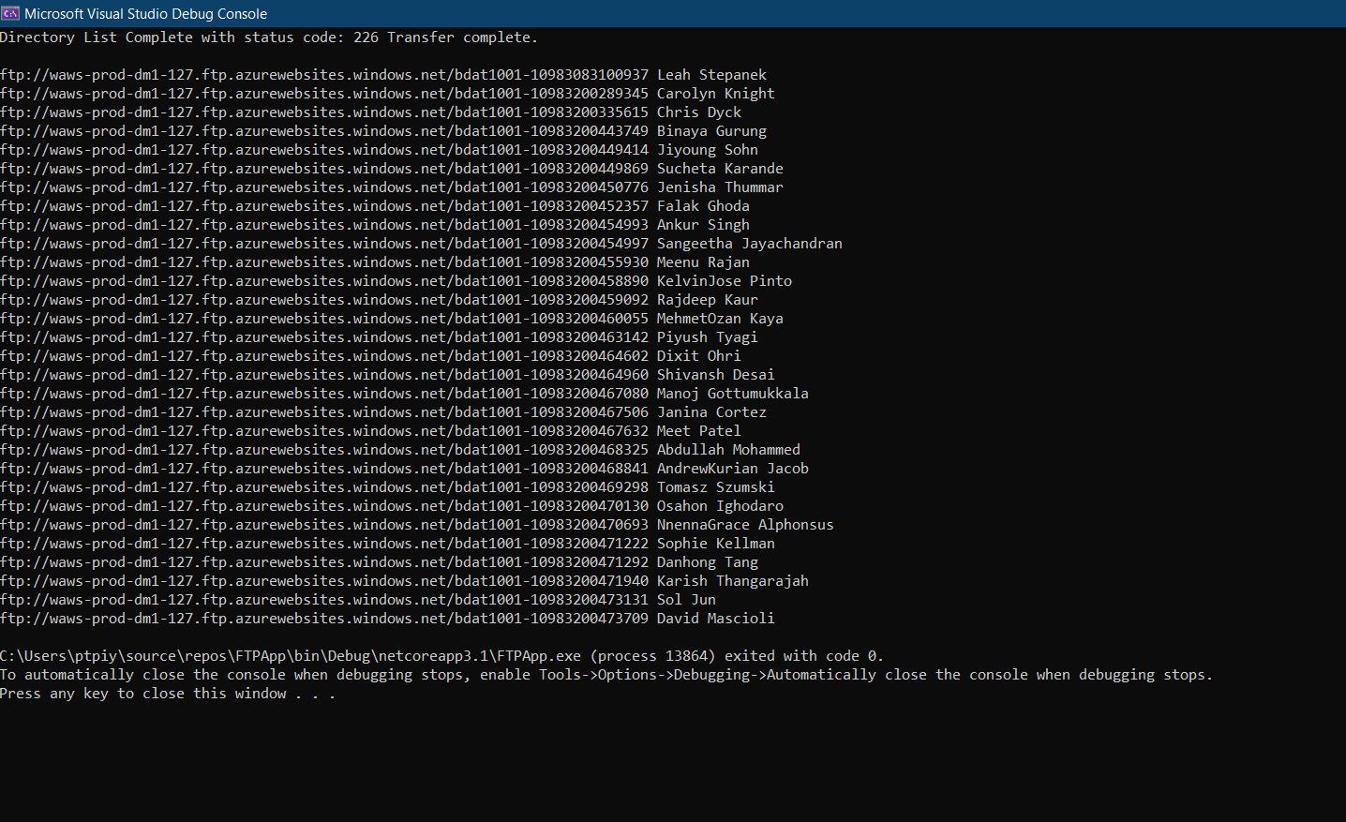

Extract the data from your directory

1. In your directory, you should be able to see the files named info.csv and myimage.jpg
2. Report on the files in the directory
3. Extract the data from these files
4. *If you have not already done so*, output your myimage.jpg file as Base64 to a new column named ImageData in your info.csv file
   1. Convert your image from a file to Base64 then add it into your CSV file programmatically and save your info.csv to the FTP

Csv and Image download

